**Screenshots/Outputs**

**Tensor Manipulations & Reshaping**

**Task: Tensor Reshaping & Operations**

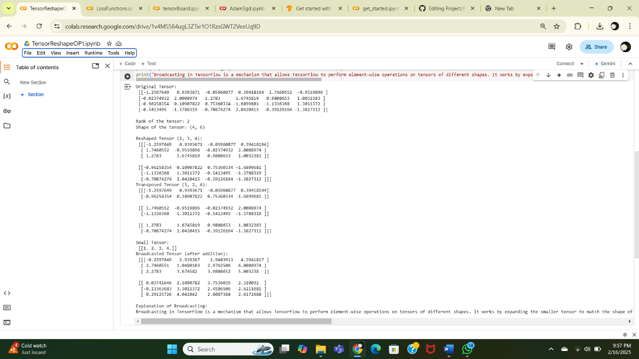

1. **Loss Functions & Hyperparameter Tuning**

**Task: Implement and Compare Loss Functions**

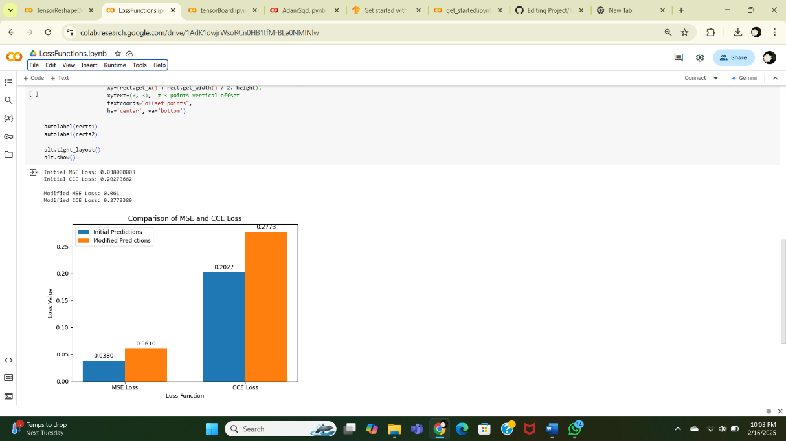

**3.Train a Model with Different Optimizers**

**Task: Train MNIST Model with Adam & SGD**

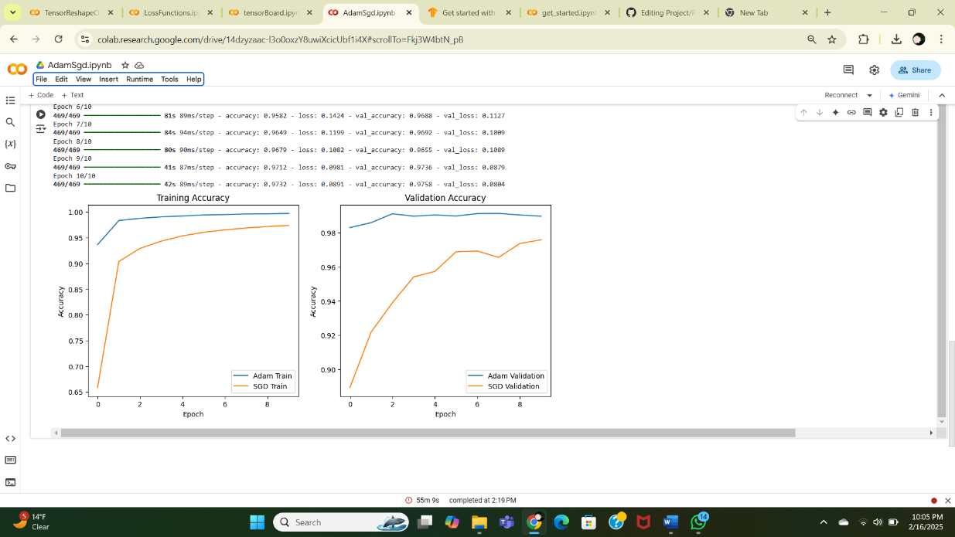

**4.Train a Neural Network and Log to TensorBoard**

